DWA V&V System — Design Amendment 001
Amendment No:
001
Date:
24 March 2026
Source:
Client feedback session
Status:
Applied
Applies to:
Solution Design Document v1.0, Data Models, Architecture Diagrams

Summary of Changes
# | Change | Type | Impact
1 | WARMS integration removed — all data via eWULAAS | Removed | High — integration architecture
2 | Water user input capability across all control points | Additive | Medium — workflow + portal
3 | V&V case number auto-generation (business rule TBD) | Additive | Low — new field on FileMaster
4 | Property subdivision/consolidation status tracking | Additive | Medium — data model + UI
5 | Protest renamed to Appeal/Objection | Rename | Medium — model, DB, views, docs
6 | HDI indicator on user profiles | Additive | Low — new boolean field

Change 1: WARMS Integration Removed
Removed WARMS system integration is no longer required
Rationale: The V&V system will now receive all required data (property data, WARMS registration numbers, owner data) from eWULAAS. V&V output (ELU determinations) will be pushed back to eWULAAS. There is no direct WARMS integration.

Before
- WARMS → V&V: Daily batch import (new records, ownership changes)
- V&V → WARMS: Real-time API call on Letter 3 issuance (update ELU volumes)
- V&V → eWULAAS: On-demand pre-population for licence applications

After
- eWULAAS → V&V: Inbound data feed (property data, WARMS reg numbers, owner data)
- V&V → eWULAAS: Outbound ELU output (on Letter 3 / ELU confirmation)
- No WARMS integration
Affected artefacts: 13-external-integrations.mmd [AMENDED],

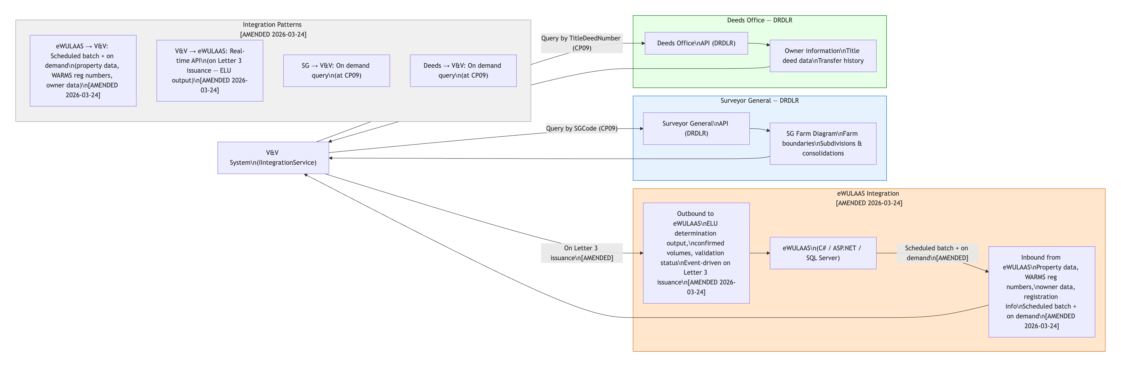

01-system-architecture.mmd [AMENDED],
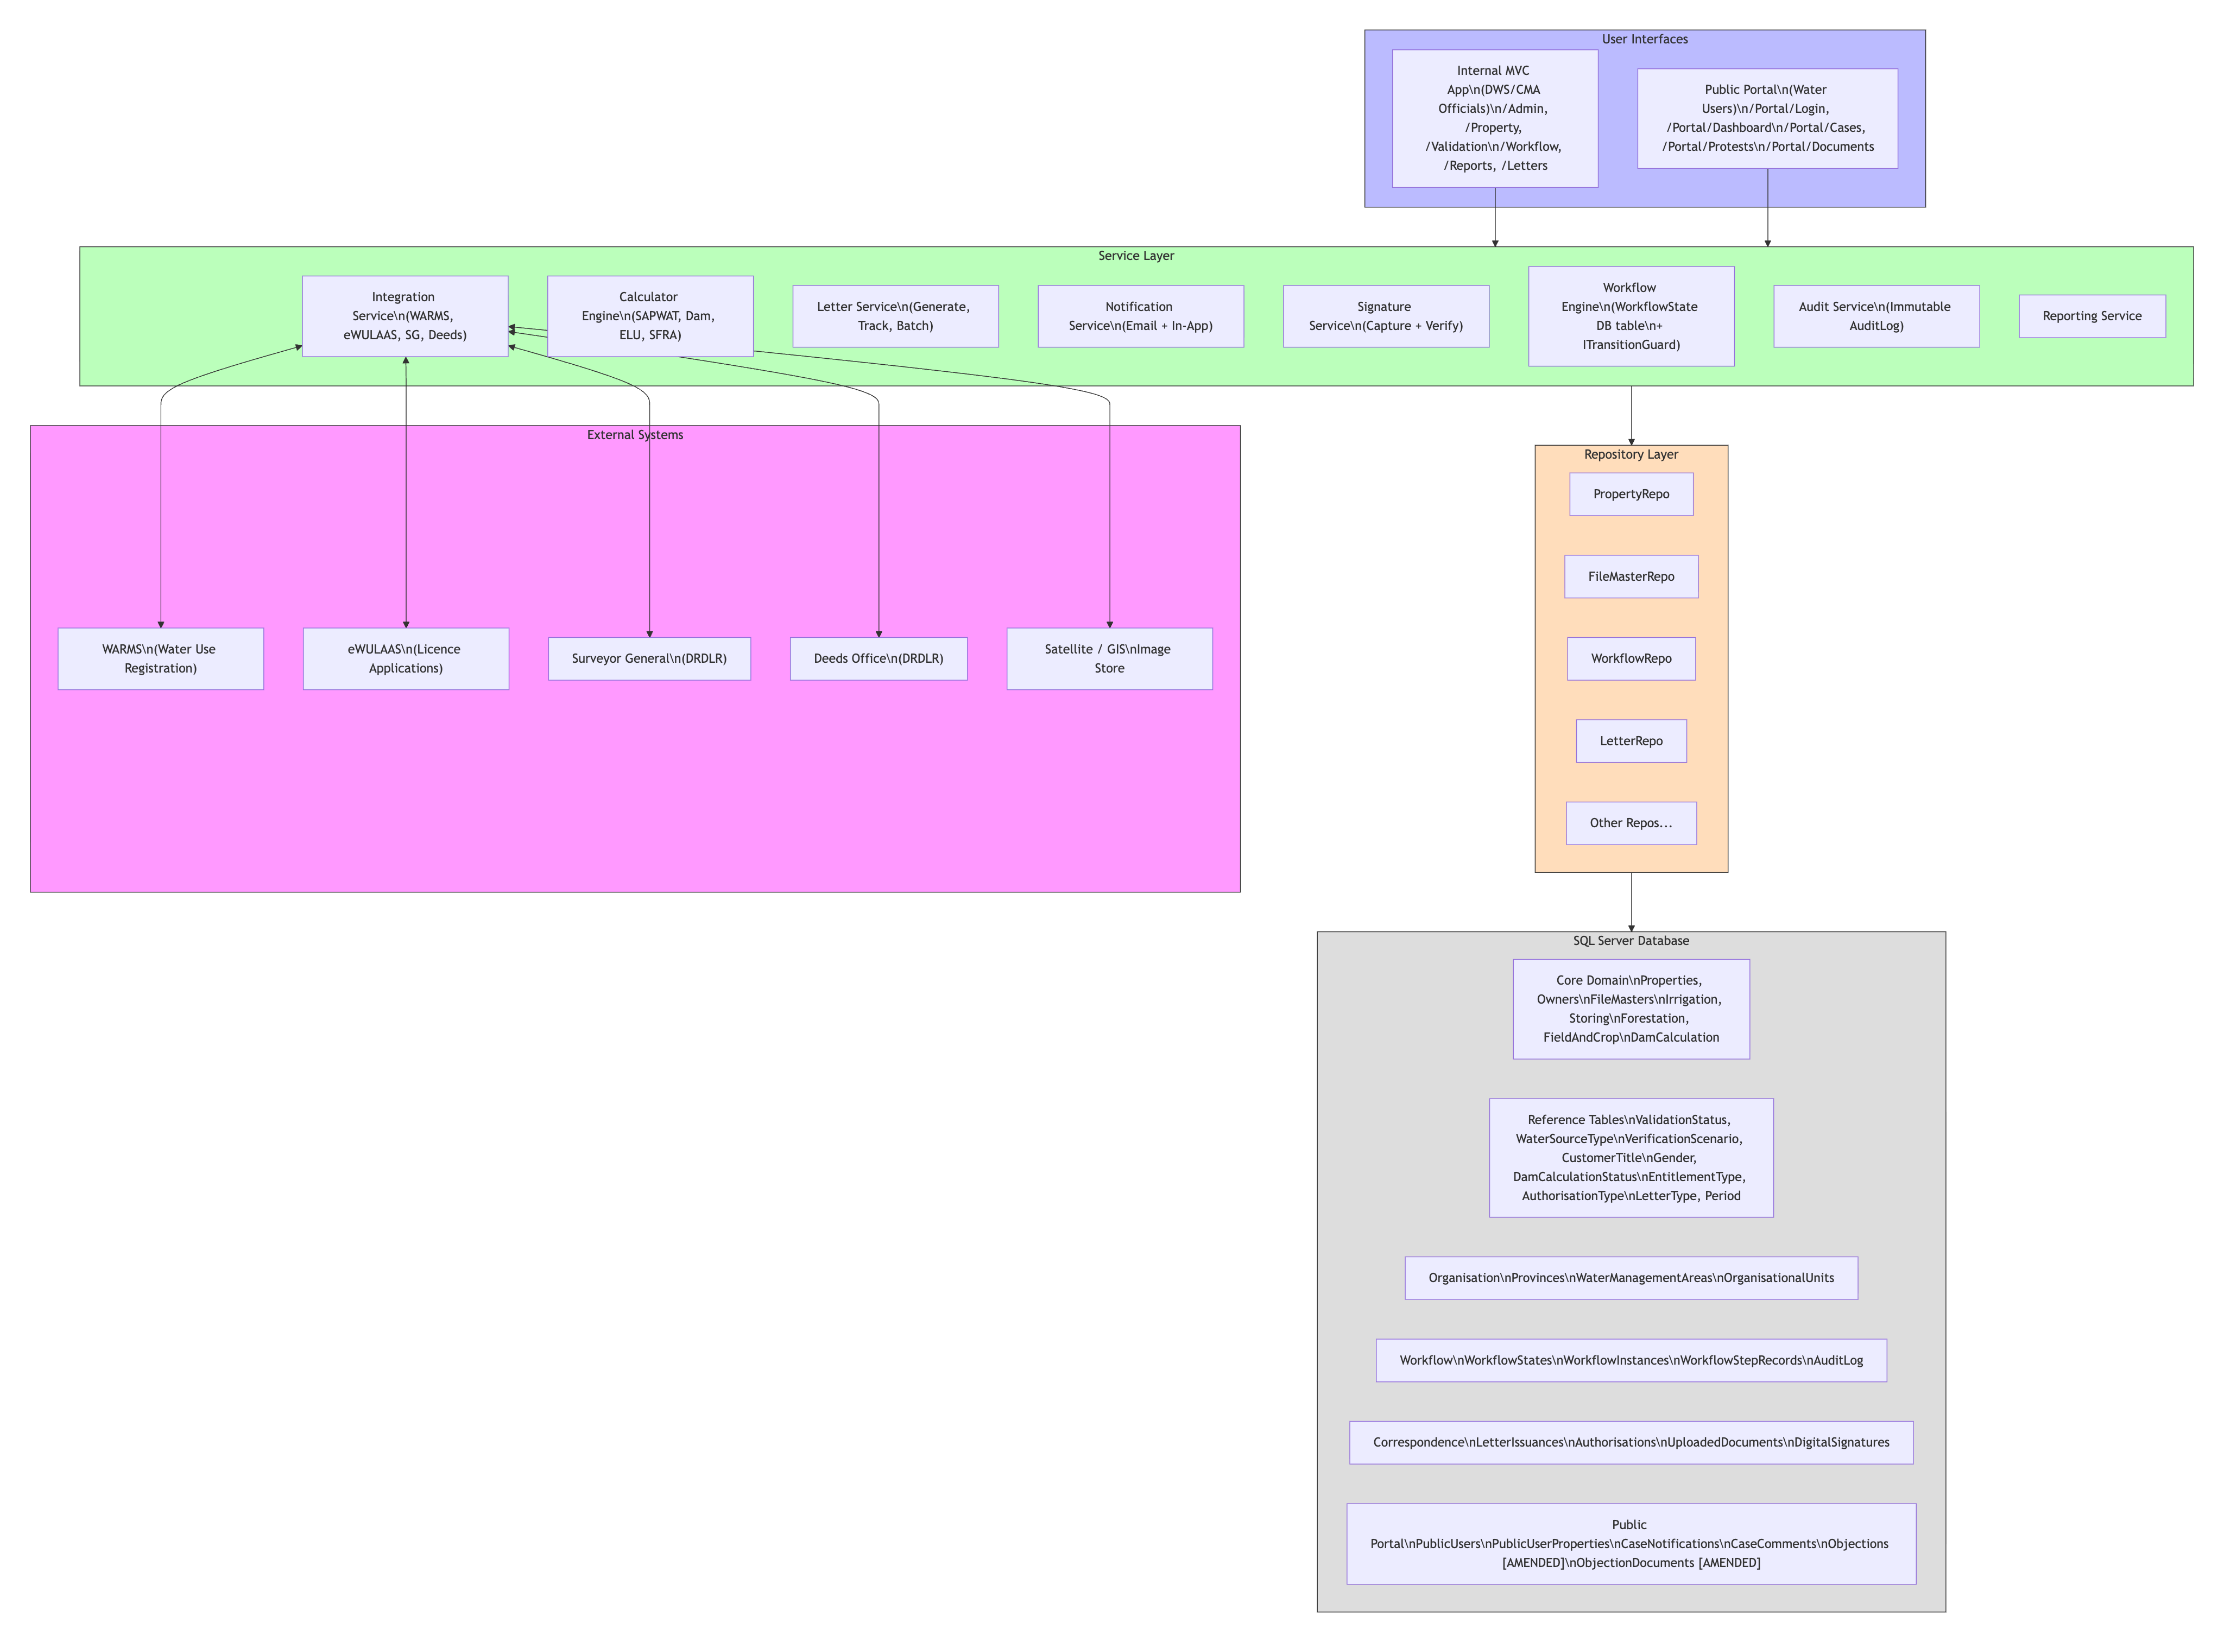

Design Document §8 External Integrations

Change 2: Water User Input Across All Control Points
Additive Workflow must support water user inputs at any control point
Rationale: DWS officials may not have all required information at certain control points. Water users must be able to submit supporting information (documents, evidence, responses) via the public portal or other communication channels. This applies across all CPs, not just during the Section 35 letter process.

New Entity: WaterUserInput
Field | Type | Description
InputId | Guid (PK) | Primary key
FileMasterId | Guid (FK) | Which V&V case this relates to
PublicUserId | Guid? (FK) | External user who submitted (nullable if submitted via other means)
ControlPoint | string | Which CP this input relates to (e.g. "CP06", "CP09")
InputType | string | Document | Comment | Evidence | Response
Description | string | Description of the submitted information
SubmittedDate | DateTime | When it was submitted
Status | string | Pending | Reviewed | Accepted | Rejected
ReviewedById | Guid? (FK) | DWS official who reviewed it

Affected artefacts: erd-04-case-management-and-workflow.mmd [AMENDED],
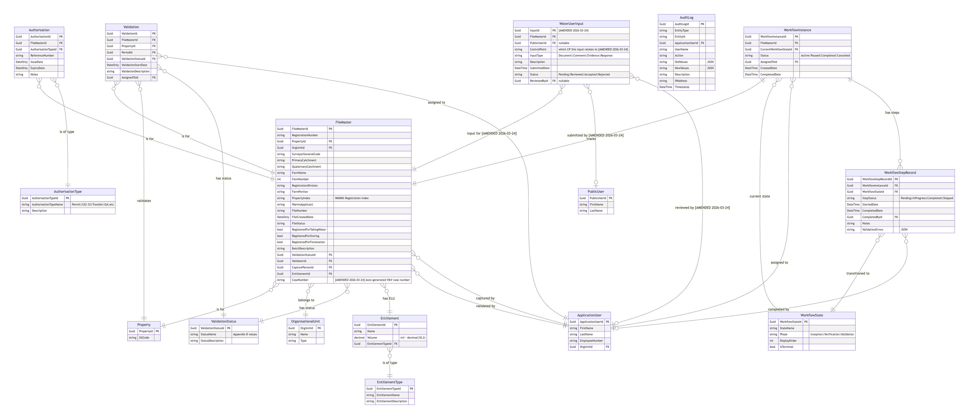

02-workflow-phases.mmd [AMENDED], 12-public-portal.mmd [AMENDED],
Design Document §5 Workflow Engine, §7 External Portal

Change 3: V&V Case Number Auto-Generation
Additive New CaseNumber field on FileMaster
Rationale: A V&V case number will be auto-generated based on a business rule still to be furnished by DWS. This is distinct from the WARMS RegistrationNumber.

Model Change
FileMaster.CaseNumber — nullable string, will be populated by the system once the business rule is defined.
Affected artefacts: Models/FileMaster.cs, erd-04-case-management-and-workflow.mmd [AMENDED]
, Design Document §4 Data Model

Change 4: Property Subdivision & Consolidation
Additive Property status tracking and parent-child lineage for subdivided/consolidated properties
Rationale: When a property is subdivided, the original property record is maintained with status "Subdivided" and new property records are created inheriting selected attributes. When multiple properties are consolidated, a single new property is created and the originals are marked "Consolidated".

New Fields on Property
Field | Type | Description
PropertyStatus | string? | Active | Consolidated | Subdivided
ParentPropertyId | Guid? (FK, self-ref) | Points to the original property before subdivision/consolidation

Behaviour
- Subdivision: Original property → status = "Subdivided". New child properties created with ParentPropertyId pointing to original. Child properties inherit: SGCode prefix, WMA, QuaternaryDrainage, Address.
- Consolidation: Original properties → status = "Consolidated". One new child property created. Each original's PropertyStatus set to "Consolidated". The new property's ParentPropertyId references one of the originals (or a separate consolidation record).
Affected artefacts: Models/Property.cs, erd-02-property-and-ownership.mmd [AMENDED], Design Document §4 Data Model, §6 Property Management

Change 5: Protest Renamed to Appeal/Objection
Rename All references to "Protest" changed to "Objection" (or "Appeal/Objection" in user-facing text)
Rationale: Client prefers the terminology "Appeal" or "Objection" over "Protest", particularly where V&V has been finalised.

Entity Renames
Before | After
Protest | Objection
ProtestId | ObjectionId
ProtestDocument | ObjectionDocument
DbSet<Protest> Protests | DbSet<Objection> Objections
DbSet<ProtestDocument> ProtestDocuments | DbSet<ObjectionDocument> ObjectionDocuments
Affected artefacts: Models/Protest.cs → renamed content, Models/ProtestDocument.cs → renamed content, DatabaseContexts/ApplicationDBContext.cs, erd-06-public-portal.mmd [AMENDED], 12-public-portal.mmd [AMENDED], 01-system-architecture.mmd [AMENDED], All unit tests referencing Protest, Design Document §7 External Portal

Change 6: HDI Indicator on User Profiles
Additive HDI (Historically Disadvantaged Individual) boolean indicator
Rationale: DWS requires tracking of HDI status for reporting and transformation monitoring. HDI refers to Black people and women in South Africa, as defined in relevant legislation.

Fields Added
Entity | Field | Type
PublicUser | IsHDI | bool (default false)
PropertyOwner | IsHDI | bool (default false)
Affected artefacts: Models/PublicUser.cs, Models/PropertyOwner.cs, erd-02-property-and-ownership.mmd [AMENDED], erd-06-public-portal.mmd [AMENDED], Design Document §4 Data Model

Amended Diagrams Index
The following diagrams have been amended in-place with [AMENDED 2026-03-24] annotations. Updated SVG renders are in docs/diagrams/svg/.
Diagram | Changes Applied
01-system-architecture.mmd | Protest→Objection rename in portal DB section
02-workflow-phases.mmd | Water User Input annotation box added to Phase 2
12-public-portal.mmd | Protest→Objection; Water User Input capability added
13-external-integrations.mmd | WARMS removed; eWULAAS made bidirectional
erd-02-property-and-ownership.mmd | Property status/lineage; HDI indicator on PropertyOwner
erd-04-case-management-and-workflow.mmd | CaseNumber on FileMaster; WaterUserInput entity
erd-06-public-portal.mmd | Protest→Objection; HDI on PublicUser

Outstanding Items (Pending Client Input)
Item | Status | Notes
V&V case number business rule | Awaiting specification | CaseNumber field added but generation logic pending
Property attribute inheritance rules for subdivision | Awaiting specification | Which attributes inherit to child properties needs defining
eWULAAS data feed format and schedule | Awaiting specification | API contract / file format for inbound data from eWULAAS

Amendment 001 — Applied 24 March 2026. Prepared by the V&V System development team.

